Health and Human Development Outcome 2 SAC – Structured Questions

question ONE (TEN marks)
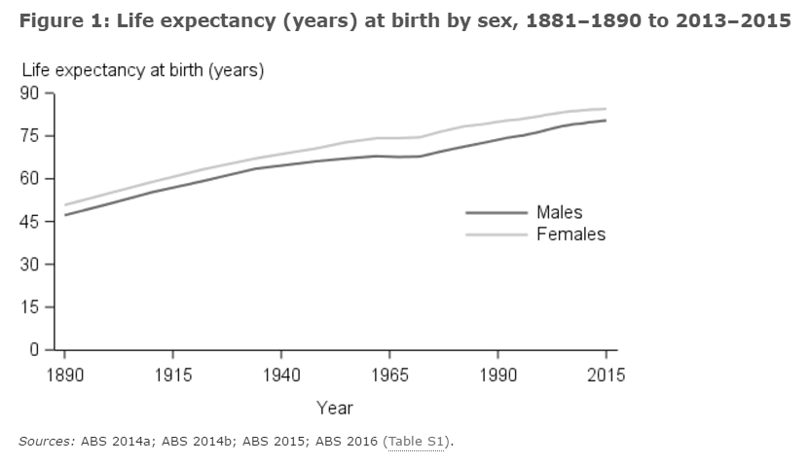
- describe the change in life expectancy over time in australia. 2 marks

__________________________________________________________________________________________________________________________
__________________________________________________________________________________________________________________________
__________________________________________________________________________________________________________________________
__________________________________________________________________________________________________________________________
__________________________________________________________________________________________________________________________
- briefly describe two ways that ‘old’ public health contributed to this change. 4 marks

__________________________________________________________________________________________________________________________
__________________________________________________________________________________________________________________________
__________________________________________________________________________________________________________________________
__________________________________________________________________________________________________________________________
__________________________________________________________________________________________________________________________
__________________________________________________________________________________________________________________________
- identify one improvement in relation to medical technology that has assisted in the change in life expectancy. 1 mark

__________________________________________________________________________________________________________________________
__________________________________________________________________________________________________________________________
__________________________________________________________________________________________________________________________
- briefly explain medicare. 1 mark

__________________________________________________________________________________________________________________________
____________________________________________________________________________________________________________________________________________________________________________________________________________________________________________________
- explain how medicare may have contributed to the change in life expectancy shown in the graph. 2 marks

__________________________________________________________________________________________________________________________
__________________________________________________________________________________________________________________________
__________________________________________________________________________________________________________________________
__________________________________________________________________________________________________________________________
question TWO (SEVEN marks)
two models of health are the biomedical and social models.

- briefly explain what is meant by the ‘biomedical model’ of health. 2 marks

__________________________________________________________________________________________________________________________
__________________________________________________________________________________________________________________________
__________________________________________________________________________________________________________________________
__________________________________________________________________________________________________________________________
__________________________________________________________________________________________________________________________
- identify one cause of premature death in australia and explain how the biomedical and social models of health could work to address it. 5 marks

__________________________________________________________________________________________________________________________
__________________________________________________________________________________________________________________________
__________________________________________________________________________________________________________________________
__________________________________________________________________________________________________________________________
__________________________________________________________________________________________________________________________
__________________________________________________________________________________________________________________________
__________________________________________________________________________________________________________________________
__________________________________________________________________________________________________________________________
__________________________________________________________________________________________________________________________

question THREE (EIGHT marks)
the national disability insurance scheme (ndis) and the pharmaceutical benefits scheme (pbs) are two components of australia’s health system.

- briefly explain how the national disability insurance scheme reflects two principles of the social
model of health. 4 marks

__________________________________________________________________________________________________________________________
__________________________________________________________________________________________________________________________
__________________________________________________________________________________________________________________________
__________________________________________________________________________________________________________________________
__________________________________________________________________________________________________________________________
__________________________________________________________________________________________________________________________
__________________________________________________________________________________________________________________________
__________________________________________________________________________________________________________________________
__________________________________________________________________________________________________________________________
__________________________________________________________________________________________________________________________
- briefly explain how the pharmaceutical benefits scheme promotes equity and access in relation to
health care. 4 marks
__________________________________________________________________________________________________________________________
__________________________________________________________________________________________________________________________
__________________________________________________________________________________________________________________________
__________________________________________________________________________________________________________________________
__________________________________________________________________________________________________________________________
__________________________________________________________________________________________________________________________
__________________________________________________________________________________________________________________________
__________________________________________________________________________________________________________________________
__________________________________________________________________________________________________________________________
__________________________________________________________________________________________________________________________
__________________________________________________________________________________________________________________________

question FOUR (EIGHT marks)
select either smoking, road safety or skin cancer and answer the following questions.

issue selected _______________________________________________________________________________________________________________
- outline two reasons why was the selected issue targeted for health promotion in australia. 2 marks

__________________________________________________________________________________________________________________________
__________________________________________________________________________________________________________________________
__________________________________________________________________________________________________________________________
__________________________________________________________________________________________________________________________
__________________________________________________________________________________________________________________________
__________________________________________________________________________________________________________________________

- use three action areas of the ottawa charter to explain how the selected issue has been targeted in australia. 6 marks

__________________________________________________________________________________________________________________________
__________________________________________________________________________________________________________________________
__________________________________________________________________________________________________________________________
__________________________________________________________________________________________________________________________
__________________________________________________________________________________________________________________________
__________________________________________________________________________________________________________________________
__________________________________________________________________________________________________________________________
__________________________________________________________________________________________________________________________
__________________________________________________________________________________________________________________________
__________________________________________________________________________________________________________________________
__________________________________________________________________________________________________________________________
__________________________________________________________________________________________________________________________
__________________________________________________________________________________________________________________________
__________________________________________________________________________________________________________________________
__________________________________________________________________________________________________________________________
__________________________________________________________________________________________________________________________

question Five (Thirteen marks)
dietary risks that contribute significantly to burden of disease in australia are high intake of fat salt and sugar and low intake of fibre.

- discuss two ways that the australian dietary guidelines work to promote fibre intake. 4 marks

__________________________________________________________________________________________________________________________
__________________________________________________________________________________________________________________________
__________________________________________________________________________________________________________________________
__________________________________________________________________________________________________________________________
__________________________________________________________________________________________________________________________
__________________________________________________________________________________________________________________________
__________________________________________________________________________________________________________________________
__________________________________________________________________________________________________________________________

- identify the organisation responsible for developing the healthy eating pyramid. 1 mark

__________________________________________________________________________________________________________________________
- explain how the healthy eating pyramid can assist in reducing intake of fat, salt and sugar. 2 marks

__________________________________________________________________________________________________________________________
__________________________________________________________________________________________________________________________
__________________________________________________________________________________________________________________________
__________________________________________________________________________________________________________________________
__________________________________________________________________________________________________________________________
__________________________________________________________________________________________________________________________
__________________________________________________________________________________________________________________________
- identify and briefly explain another way the organization identified in part b. work to reduce the
intake of fat, salt and sugar in australia. 2 marks

__________________________________________________________________________________________________________________________
__________________________________________________________________________________________________________________________
__________________________________________________________________________________________________________________________
__________________________________________________________________________________________________________________________
__________________________________________________________________________________________________________________________
- identify and briefly explain two barriers to bringing about dietary change in australia. 4 marks

__________________________________________________________________________________________________________________________
__________________________________________________________________________________________________________________________
__________________________________________________________________________________________________________________________
__________________________________________________________________________________________________________________________
__________________________________________________________________________________________________________________________
__________________________________________________________________________________________________________________________
__________________________________________________________________________________________________________________________
__________________________________________________________________________________________________________________________
__________________________________________________________________________________________________________________________
__________________________________________________________________________________________________________________________
_________________________________________________________________________________________________________________________
_________________________________________________________________________________________________________________________
question six (FOUR marks)
the be deadly, get healthy program aims to improve the health of aboriginal families and reduce chronic disease in the baw baw shire in the gippsland area of victoria (vic).

the program uses a family-based approach, where children and parents are encouraged to participate in the program together so they learn long-term healthy behaviours.

the program involves an initial health assessment on joining the program and participation in regular physical activity sessions. the weekly physical activity sessions include:
- group walks
- gym circuits
- cardio strengthening exercises.

the be deadly, get healthy program was developed by the west gippsland healthcare group (wghg) in partnership with ramahyuck district aboriginal corporation (rdac). the program also aims to strengthen the relationship between rdac and wghg.

the program is supported by the vicoutreach aboriginal health program administered by rural workforce agency vic with funding from the australian government.

discuss the potential effectiveness of the be deadly, get healthy program.

__________________________________________________________________________________________________________________________
__________________________________________________________________________________________________________________________
__________________________________________________________________________________________________________________________
__________________________________________________________________________________________________________________________
__________________________________________________________________________________________________________________________
_________________________________________________________________________________________________________________________
_________________________________________________________________________________________________________________________
_________________________________________________________________________________________________________________________
_________________________________________________________________________________________________________________________
_________________________________________________________________________________________________________________________
_________________________________________________________________________________________________________________________
_________________________________________________________________________________________________________________________

